6.Develop a system using UML for implementing E-Ticketing System

Use case diagram:

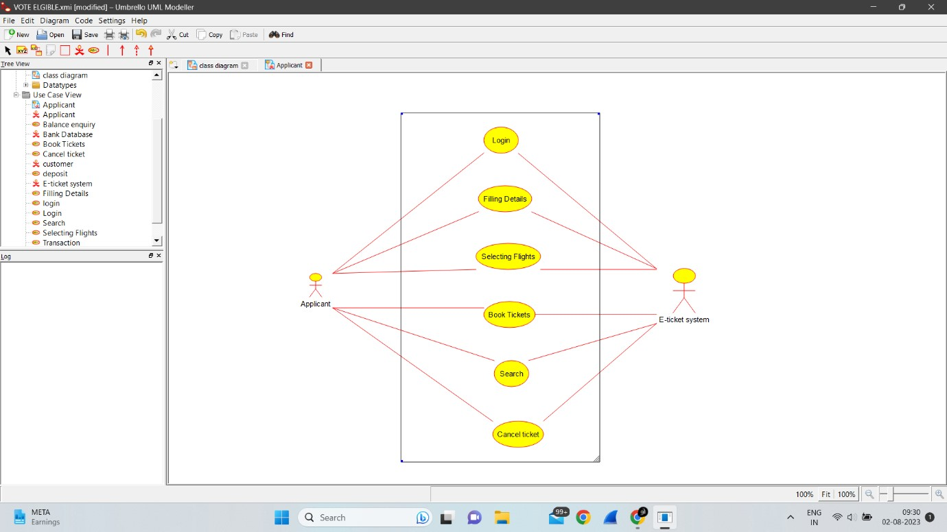

Class diagram:

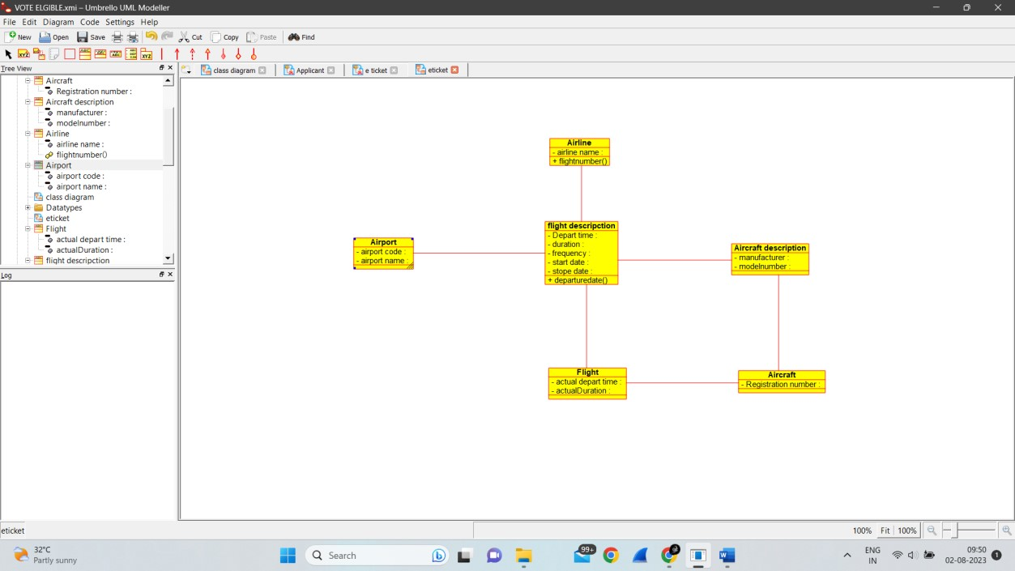

Collaboration diagram:

